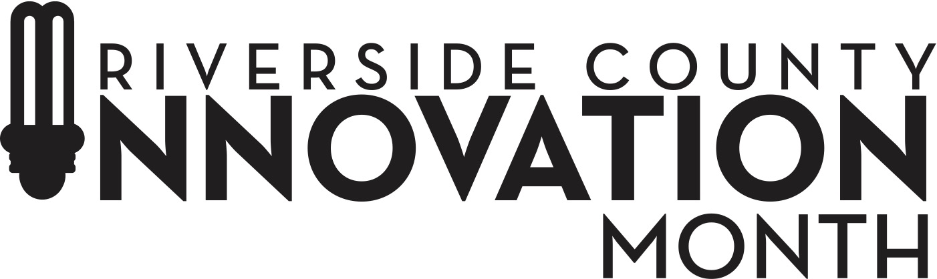

SOUTHWEST RIVERSIDE COUNTY REGIONAL FAST PITCH
STARTUP APPLICATION

- Name of business/startup ________________________
- Contact _______________________________________
- Phone Number _________________________________
- Email/Website__________________________________
- Is your business located in any of the following cities: Wildomar, Lake Elsinore, Temecula, Menifee or Murrieta? Yes/No
- Business Location________________________________
- Brief Description of Concept/Business Model: ______________________________________________
- Has your business received venture capital/angel investment?____________________________________
- Other types of investment, such as Crowdfunding, SBIR/STTR/Grants, Institutional Loans? _______________________________________________
- Do you have a viable prototype or final product? Yes/No
- Is your business pre-revenue? Yes/No
- Have you read and understood the Riverside County Innovation Month 2024 Guidelines for Regional Fast Pitch Events? Yes/No

JUDGING CRITERIA

Judging will be based on the 5-minute pitch presentations – along with the answers to the questions that judges pose.
There are 5 different criteria with EACH being given a 1- 5 score and each given 20% weighting.
Business Model – Is this a valuable business? How likely is this company to succeed in its endeavor and will it scale to a place that it can make a MAJOR impact on the market?
Quality of Presentation – Does the presentation explain clearly, thoroughly, effectively and creatively the message so that the potential Viability and Scalability can be understood?

CRITERIA SCORE
- Value - Does this concept provide value the marketplace?
- Differentiation – Is this a new and innovative business?
- Viability and Scalability – Is there a plan and ability for this business to expand?
- Team – How strong are the founders and advisors in guiding this startup?
- Pitch Presentation – How well did the presenter convey the product?

Each of the judges will select their own 1st, 2nd and 3rd places through “force ranking” the participants.
Following the presentations and Q & A sessions, the judges will retire to determine the 1st, 2nd and 3rd place winners.

Note: Only startups that meet the criteria for the Riverside County Innovation Month Pitch Finale may be passed on from the regional pitch competition to the finale.

